Name:  Class: | ____________________________________  ________________ |  | Date:_________
 | Year 8 Mathematics  Mini-Test 2, 2019  Topic – Perimeter, Area and Volume |  | $$\frac{ }{41}$$
Total Time: | 40 min
Weighting: | 5 %
Equipment: | 1 page of notes and a calculator

Question 1 3 marks

Convert the following units:

- 27mm = ________________________________ cm

- 0.00084m² = ____________________________ cm²

- 7.26m³ = ________________________________cm³

Question 2 10 marks

- What is the definition of perimeter: ___________________________________________________

_________________________________________________________________________________

- Find the perimeter of the following shapes. All units are in centimetres:

a. Working Out:  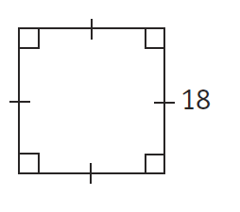  Answer: ________________ | b. Working Out:  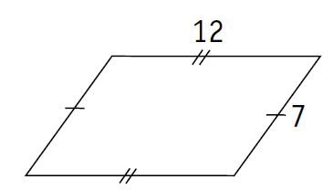  Answer: ________________
c. Working Out:  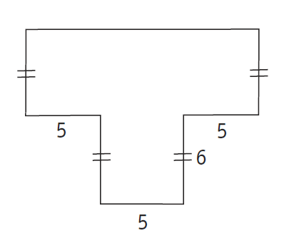  Answer: ________________ | d. If the perimeter of a square is 48 centimetres, find the length of each side.  Answer: ________________

Question 3 11 marks

- What is the definition of area: ________________________________________________________

_________________________________________________________________________________

- Find the area of the following shapes.

a. Working Out:  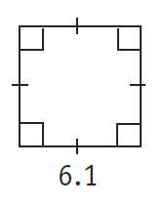  6.1 cm m  Answer: ________________ | b. Working Out:  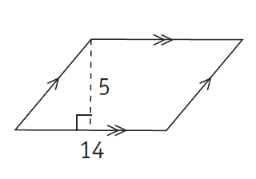  14 m  5 m  Answer: ________________
c. Working Out:  8 mm  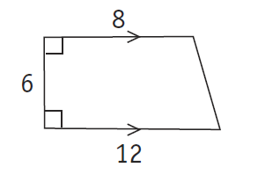  1.2 cm  6 mm  Answer: ________________ | d. (Units is cm) Working Out:  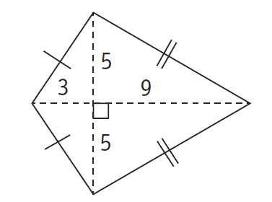  Answer: ________________

Question 4 5 marks

- What is the definition of volume: ______________________________________________________

_________________________________________________________________________________

- Find the volume of the following shapes.

a. Working Out:  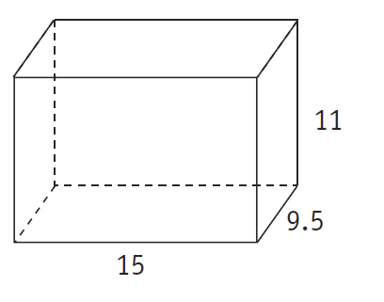  11 cm  9.5 cm  15 cm  6.1 cm m  Answer: ________________ | b. Working Out:  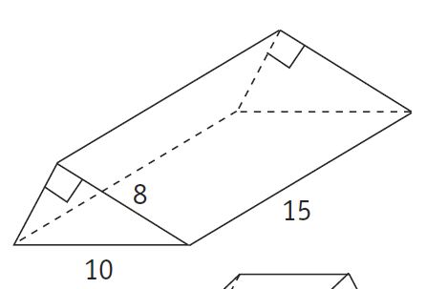  10 km  8 km  15 km  Answer: ________________
Question 5 12 marks

- A rectangular swimming pool is 6 m × 8.5 m.
  - What is the area of the swimming pool’s surface?

- The swimming pool is surrounded by a concrete path that is 1 m wide and 10 cm deep
  - What are the dimensions of the swimming pool including the path?

  - What volume of concrete will be needed to make the path?

End of Test

